PART A
(Part A: TO BE REFERRED BY STUDENTS)
Experiment No. 10
A.1 AIM:
- Create database and documents using mongo DB database and show the result based on some condition.
- Perform CRUD operation in MongoDB using MongoDB shell
A.2 Pre requisite:
Knowledge of NoSQL, MongoDB commands.
A.3 Outcome:
After successful completion of this experiment students will be able to

- Recognize the importance of NoSQL database over SQL in database management systems.
- Use NoSQL using MongoDB.
- CRUD operations using MongoDB

A.4 Theory:
MongoDB is a free and open-source cross-platform document-oriented database. Classified as a NoSQL database, MongoDB avoids the traditional table-based relational database structure in favor of JSON-like documents with dynamic schemas, making the integration of data in certain types of applications easier and faster.
Below given table shows the relationship of RDBMS terminology with MongoDB
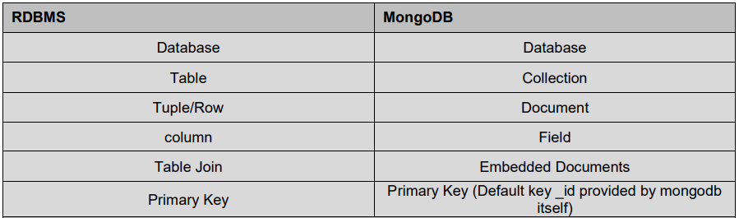
MongoDB Create database:
MongoDB use DATABASE_NAME is used to create database. The command will create a new database, if it doesn't exist otherwise it will return the existing database.
Task:
Syntax: use DATABASE_NAME
1.Show databases
show dbs
use college
db.student
2.Show collections
show collections
3 insertOne(),insertMany()
4.updateOne(),updateMany()
5 deleteOne(),deleteMany()
6 Display using find()

Examples:
Mongo DB Commands:

Create Collection
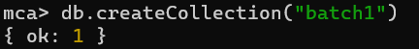
Delete Collection
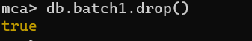
Insert One
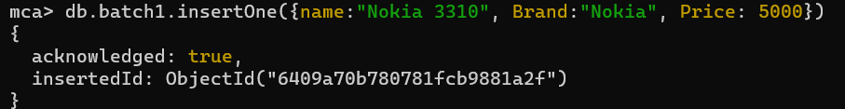
Insert Many
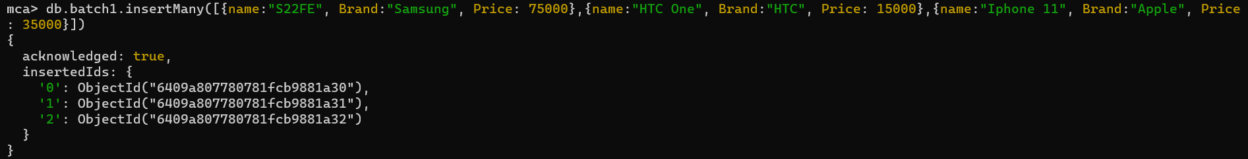
Update One
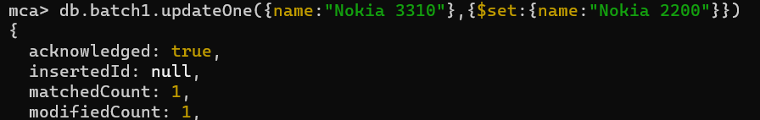
Update One:
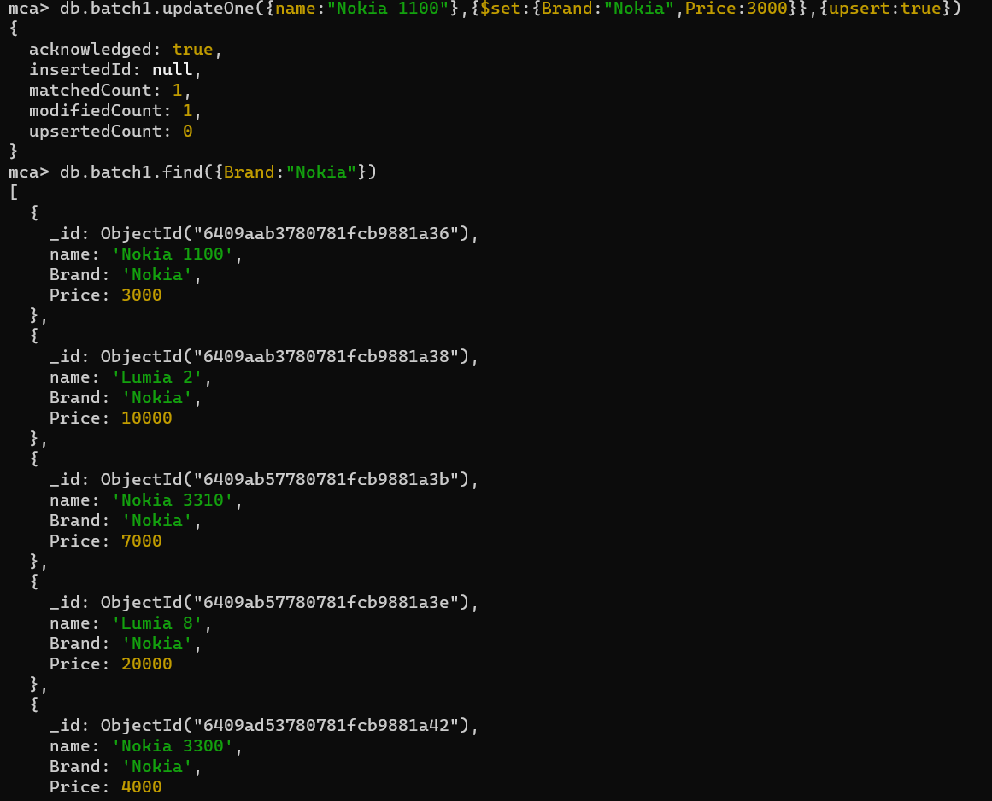
Delete One
Delete Many
Find
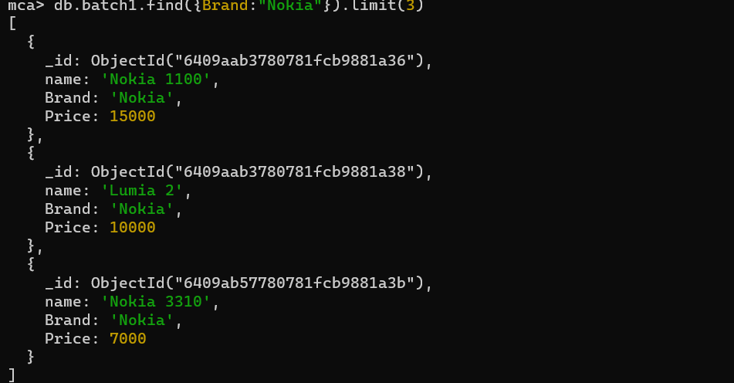
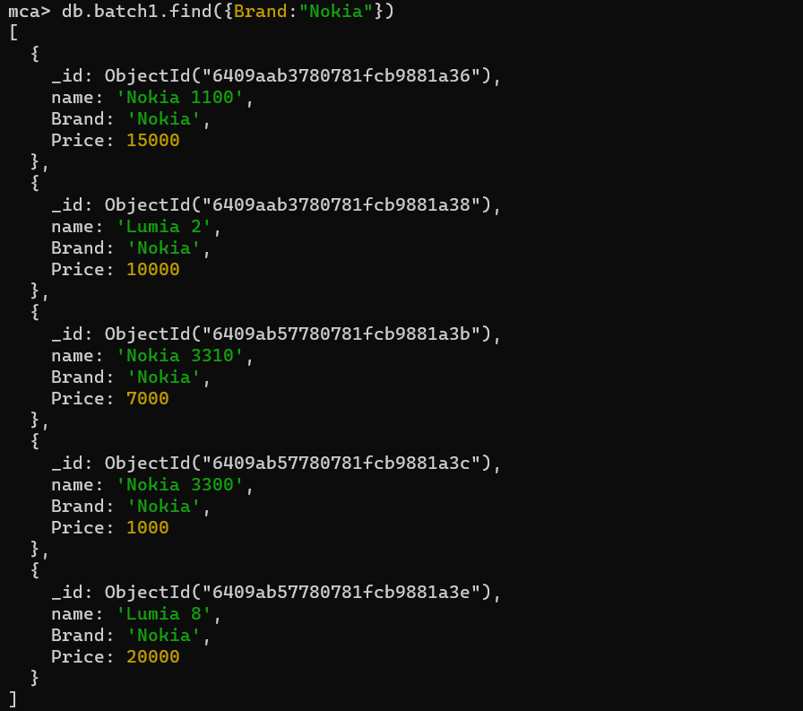

PART B
(PART B: TO BE COMPLETED BY STUDENTS)
(Students must submit the soft copy as per following segments within two hours of the practical. The soft copy must be uploaded on the Blackboard or emailed to the concerned lab in charge faculties at the end of the practical in case the there is no Black board access available)
Roll No. : | Name:
Class : | Batch :
Date of Experiment : | Date/Time of Submission :
Grade :

B.1 Tasks given in PART A to be completed here
(Paste your answers and output here)

B.2 Conclusion:
(Students must write the observations and learning based on their understanding built about the subject matter and inferences drawn)

B.3 Question of Curiosity
(To be answered by student based on the practical performed and learning/observations)
1. Differentiate between NoSQL and SQL?
2. Explain the advantages of MongoDB.

